1.

select *

from sales_order

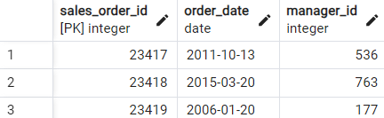

2.

select *

from sales_order

where order_date > to_date( '2016-01-01', 'YYYY-MM-DD')

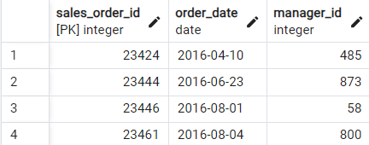

3.

select *

from sales_order

where order_date between to_date( '2016-01-01', 'YYYY-MM-DD') and to_date( '2016-07-15', 'YYYY-MM-DD')

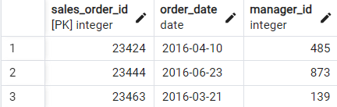

4.

select *

from manager

where manager_first_name = 'Henry'

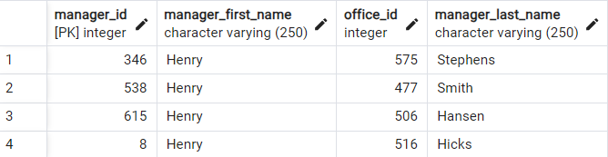

5.

select s.sales_order_id,

m.manager_first_name

from sales_order s left join manager m

on s.manager_id = m.manager_id

where m.manager_first_name = 'Henry'

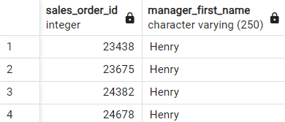

6.

select distinct

country

from city

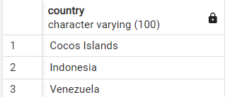

7.

select distinct

country,

region

from city

where region is not null

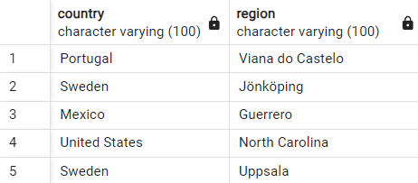

8.

select

country,

count(city) as count_city

from city

group by 1

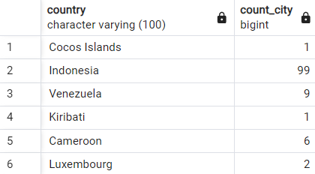

9.

select

sum(s_count.product_qty) as sum_qty

from sales_order_line s_count left join sales_order s_id

on s_count.sales_order_id = s_id.sales_order_id

where s_id.order_date between to_date ('2016-01-01', 'YYYY-MM-DD') and to_date( '2016-01-30', 'YYYY-MM-DD')

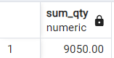

10.

select

distinct city_name as sname

from city

union all

select

distinct region as sname

from city

union all

select

distinct country as sname

from city

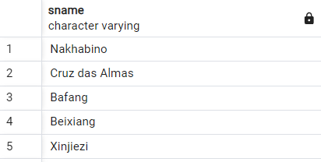

11.

select

f_name,

l_name,

sum_

from (

select

m.manager_id as m_id,

m.manager_first_name as f_name,

m.manager_last_name as l_name,

sum(s_sum.product_price) as sum_,

RANK() OVER (ORDER BY sum(s_sum.product_price) DESC) as rank_

from

sales_order s_id

left join

manager m on s_id.manager_id = m.manager_id

left join

sales_order_line s_sum on s_id.sales_order_id = s_sum.sales_order_id

where

s_id.order_date between to_date('2016-01-01', 'YYYY-MM-DD') and to_date('2016-01-31','YYYY-MM-DD')

group by

m.manager_id, m.manager_first_name, m.manager_last_name

) as ranked_sales

where rank_ = 1